April 2023 Lamont Elementary Student Advisory Committee
Hybrid Meeting on Wednesday, April 4 2023

In Attendance: Krista Skinner, Heather Rideout, Kjersti Wytrykush, Paul Mckay, Tami Richert, Nadia Chopping, Colleen Holowaychuck, Reena, , Ginalyn Kurylo, Carla Graham, Candace Bryks

Meeting called to order at 6:06 pm

- Agenda accept by Nadia Chopping, second by Candace Bryks
- Minutes from February meeting accepted by Heather Rideout and seconded by Nadia Chopping. (All Approved)

Principal Report (Presented by Paul Mckay)

Principal Report for April 2023
It’s nice to see everyone back again. The longer days have really been a boost for me, and I hope everyone is feeling well. Since we last met our school has been busy as usual. The month of March was highlighted by our Ukrainian cultural program working on the Pysanka. Thanks to the LUBA group and all the volunteers that made this possible as well as the yummy perogy lunch we had when we returned from spring break. We also had our grade one group attend a field trip to Telus World of science. I was able to join them, and we had a great time. Looking ahead to April we are looking forward to Paska making, swimming field trips and a Ukrainian dance presentation. Over spring break, we had a number of students participate in our At Home Challenge to build a tower to support a basketball. We’ve received lots of entries and even some of the models were brought to school.
School Profile: Our school community has received a boost in population since returning from spring break. We’ve registered 6 new students (1 kinder, 2 grade 2’s, 1 grade 4, 1 grade 5 and 1 grade 6). We’ve also seen an increase in kindergarten enrolments for next year. We are looking at a population over 300 for next school year. School budgets come out on April 28th. After that is released, we will be able to start planning for staff configurations next year.
Staffing: Next week we will welcome Mrs. Oviatt back to teach our music program, however we are pleased to announce that Mrs. Janzen will be staying on with us on a part time basis to support our grade 1 students as a part of the governments learning gap funding. On a sad but happy note we are having two retirements this year. Starting immediately Mrs. Doris Zureski will be retired. Doris has served our school community for many years, and she will be truly missed. In her place we have hired Kasia Demonnin until the end of the year. Kasia has stepped in and done a wonderful job so far. Mrs. Wisselink will also be retiring at the end of this year. Mrs. Wesselink has been an integral part to our school and built a strong literacy program through our library. She will be missed and very tough to replace.
Playground: Once I was informed about the Friends of Lamont securing the CFEP grant I reached out to our facilities team. They informed me that the deadline for summer construction had passed and that the new playground will now be set for the summer of 2024. In the meantime, we will be planning the design and wants of the playground. Behind the scenes I have connected with our facilities department and they will be assigning a project manager to our project. The offer to tender will start in January.
Playground Reveal.pptx
Hot Lunch: Our hot lunch program got a boost this month. Thanks to the generosity of True North Oilfield LTD and Oar Contracting donating a total of $2000 we will be able to extend our program a little further in the year.
Calendar Items:
- April 6 - Formal Day
- April 7 - No School (Good Friday)
- April 10 - No School (Easter Monday)
- April 15 - Young Authors Conference
- April 17 - Paska making (Grades 1, 4, 6)
- Grade 6 Blanket Exercise @ 1:00
- April 18 - Ukrainian Dancers @ 11:30
- April 19 - Comfy Cozy Day
- Leadership Meeting (Paul and Tami away)
- April 24 - Paska making (Grades 2, 3, 5)
- April 24 - 27 - Book Fair
- April 28 - Ukrainian Easter Breakfast @ 11:30 - 1:00

Discussion from Principal Report:
Krista will create a survey for the teachers to poll students.
Krista suggested that EIPS should look into standardizing documents for parent groups, including surveys, standards, etc.
Paul to confirm with EIPS that the equipment slated for removal this summer will be held until the project is able to proceed. He will also get a confirmed list of equipment for removal and standards for new equipment/ground.

Trustee Report: Presented by Colleen Holowaychuck
Lamont Elementary School Council Trustee Report – April 2023

EIPS Meetings with Municipalities
March 22, 2023 - EIPS Board met with the Town of Lamont Council
Reminder: Committee of School Councils (COSC) Meeting
The next COSC meeting will be held Wednesday, April 5, 2023, at Central office from 7:00-9:00pm.
Reminder: Alberta School Council Association Annual Conference - April 21-23, 2023
School Councils with and active ASCA membership need to apply by the deadline of April 6, 2023, to Emma Small at EIPS.
Reminder: School Council Grant
The government provided $500 per school council. There is a form to be filled out and forwarded it to central office to receive the dollars. If the dollars are not spent they will need to be returned to the government.
Budget 2023-2024
The Provincial budget was announced at the end of February. It is said to be a fairly good news budget for education, but boards are still working out the details as to how it will affect each board. EIPS board has met regarding the budget and more details on specifics will follow.

New Sherwood Heights School Build
Construction funding has been announced for the new Sherwood Heights School in Sherwood Park. The new build combines Ecole Campbell Town Elementary and Sherwood Heights Junior High into one new school on the current Sherwood Heights location.

LOGOS Program
Motion was passed at the March 16, 2023, board meeting to combine the LOGOS program, currently at two sites: Brentwood Elementary and Westboro Elementary, at Brentwood Elementary beginning September 2023. The combining of the program will help ensure that the program can continue as enrolment at both sites was declining.

2024-2027 Three-Year Capital Plan Approval
The Board approved the new plan at the March 16, 2023, board meeting. Number one on the capital plan is a new high school for Fort Saskatchewan: combining the current Rudolf Hennig Junior and Fort Saskatchewan High School into one 7-12 High school.
Next Board Meeting
April 6, 2023 - Special Board Meeting, and April 20, 2023

Town Report: Presented by Colleen Holowaychuck
Town Council Report to Lamont Elementary School – April 2023
February 28, March 14, 28, 2023 - Town Council Meetings. Highlights included:
*LHS Principal Greg Cruickshank has joined the Economic Development Committee
*May 8-12, 2023, has been proclaimed as Economic Development Week
*2022 Audited Financial Statements were approved
*The mayor will provide a letter to Elk Island National Park on the importance of retaining the golf course.
*Council gave first and second reading to the Animal Control Bylaw. It has not yet reached third reading. If you own a pet, you should familiarize yourself with the bylaw.
March 20, 21, April 6, 2023 - Budget Meetings
March 22, 2023 – Meeting with the Elk Island Public School Board
April 3, 2023 – Lamont Public Library Meeting (if anyone is interested in becoming a board member, please let me know)
Lamont Farmers’ Market will run in Lamont on Wednesday evenings from May to September 2023 from 3:30-7:30pm. Weather permitting, the event will be held outdoors at the hall parking lot. In inclement weather it will be relocated indoors.
Centenarian Recognition The town will continue to recognize residents celebrating 100 years of age with a tree planting and commemorative leaf on the recognition tree at Hillside Park. If you know anyone celebrating this milestone, please contact the Town office.
Lamont Public Library Fundraiser Bingo that was to be scheduled to be held on May 12, 2023, in the Meeting Room has been canceled. The library will hold a different fundraiser, thoughts right now are a Spaghetti Lunch on June 3, 2023 (the town-wide garage sale) and an online silent auction.
FCSS Volunteer Appreciation Dinner April 19, 2023, from 5:30-9:00pm at the hall. Supper will be provided. Comedy Act called Double Vision will be entertaining. All community volunteers are invited to attend. There is no charge for the event, but tickets are required and can be picked up at the town office until April 7, 2023.
Next Council Meeting will be held on April 11, 2023. Council meetings can be viewed on Facebook Live and the motions coming out of the meeting are posted on the town Facebook page within a day or two following the meeting.
Please view the Town Face Book page and the sign at the town office for information regarding upcoming activities and information residents may be interested in.

Treasurer’s Report: Presented by Krista Skinner
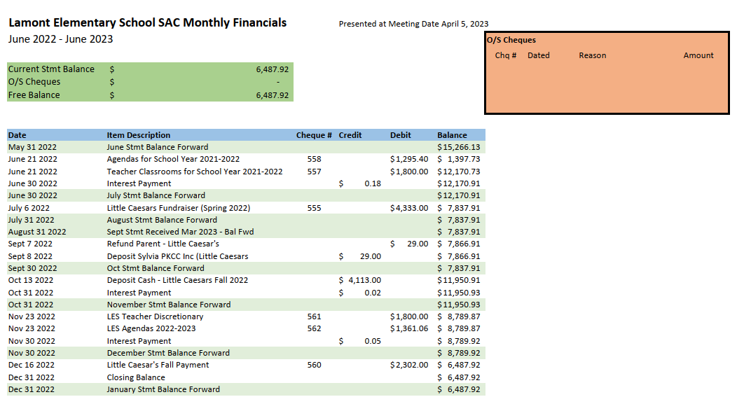

Fundraiser Update: Presented by Krista Skinner
No further fundraisers for this school year
Asking for suggestions
Little Caesars being run by the High School, therefore elementary will not run it any longer.
Fundraising Plan for next year will be presented at September meeting to make things clear as to FLESS/SAC fundraising
Reminder discussion regarding why SAC needs to fundraise – we donate at least $3000 to the school each year, currently focused on agendas for all students and classroom funds for teacher’s discretionary spending.

Friends of Lamont Report:
There will be a meeting scheduled right after the next Parent Council Meeting.

Date of next meeting (Hybrid) Wednesday, May 17 at 6:00pm

Meeting Adjourned at 6:48 pm by Heather Rideout and Krista Skinner

