**February 2023 Lamont Elementary Student Advisory Committee**

**Hybrid Meeting on Wednesday, February 15 2023**

**In Attendance:** Krista Skinner, Heather Rideout, Nicole Kammer, Paul Mckay, Tami Richert, Nadia Chopping, Colleen Holowaychuck, Diane Shandro, Bobbi Moonen, Jen Durrette, Kirby Oshust, Candace Bryks, Kristen Rolschuk Panek

**Meeting called to order at 6:06 pm**

1. **Agenda accept** by Heather Rideout
2. **Minutes from November meeting** accepted by Krista Skinner and seconded by Heather Rideout. (All Approved)

**Principal Report** (Presented by Paul Mckay)

It is nice to see everyone after a bit of a break from regular meetings. On behalf of our staff and students, thank you for the amazing Valentine’s surprise. It was a welcome treat and truly appreciated.

**Staffing:** We’ve had a number of staffing changes since we last met. Most recently we wished Mrs. Payter good luck as she heads off to have her first child at the end of March. Miss. Beach has joined us to cover the remainder of the year in grade 5. In January we welcomed Mrs. Heath to our grade 6 classroom. Mrs. Heath is covering for Miss Budd as she is now a literacy numeracy specialist supporting all grades in the afternoons. In April we will welcome back Mrs. Oviatt from her maternity leave and say goodbye to Mrs. Janzen who has done an amazing job in her role for that past couple of years. Finally, through some cost savings funding provided to us from the board we were able to hire back Mrs. Bzawy, an educational assistant who will be in our grade 2/3 class on Tuesday’s, Wednesday’s and Thursday’s for the remainder of the year.

**Activities:** Over that past couple of months, we have participated in a number of activities. Most recently many of our grade 4-6 students participated in the ski trip to Sunridge. A good time was had by all, and we came back with all the kids we left with, so we chalk that up as a success. Our volleyball club participated in a tournament at Fultonvale school in December and experienced some success and all had a good time. Basketball club has just begun, and we are looking forward to providing grade 5/6 students an opportunity to learn some basketball skills and some team skills over the next month. Of course, our Christmas concert was a big hit, and it was so nice to have everyone there in person for the first time in several years. A huge thank you to Mrs. Janzen our music teacher for putting this together.

**Returning Student Registration:** The month of February is returning student registration month and many of our families have already completed the form. Enrolment looks encouraging for next year and we will keep an eye on this process as the month progresses. Kindergarten registrations are already at 30 students.

**Fees:** Each year principals are asked to present the fee schedule for the next year. Information shared with school councils will help guide the setting of fees for next year. Below are the current fees for the 2022/23 school year. For the 2023/24 school year we are not proposing any increases.



**Highlights / Questions:**

What would the appetite be to move to a pay as you go model for field trips?

Anything we should consider adding to the fee list?

Ski Trip is an extracurricular trip along with volleyball/basketball/track

**Trustee Report**: Presented by Colleen Holowaychuck

**Lamont Elementary School Council Trustee Report – February 15, 2023**

**December Board Meeting**

Received the unaudited financial report Sept 1, 2022 – November 30, 2022

Current surplus $1.649 million (school have mostly spent 30% of their budgets, central departments have spent 25%). Decisions will be made regarding the surplus in early January.

**December Activities**

During the month of December, the Board attended various Christmas events at their respective schools. (I was able to attend the Bruderheim Christmas concert and help with the Lamont Jr/Sr High School formal day dinner)

The Board met for Christmas luncheons with the Employee Relations Group (ERG) and the Local ATA executive.

I was asked to talk to the students in Bruderheim School about Integrity as it is one of their TIGER Traits.

**Allocation of mid-year surplus.**

This allows the board to stay on top of the accumulated surplus and ensure it is in light with the reserve cap limits set at Alberta Education on August 31, 2023. For EIPS this is 3.15% of our operating budget ($6 million dollars). It also ensures today’s dollars are spent on today’s students.

1. $902,000 allocated to schools
2. $1,196,662 for computers
3. $313,295 to Early Learning and Specialized Supports Schools to where needs at schools are greatest
4. $59,000 for a term certain project manager starting March 1

**EIPS Meetings with Municipalities**

January 30, 2023 - EIPS Board met with the Town of Bruderheim Council

February 9, 2023 - EIPS Chair, Vice Chair and Superintendent met with the Mayor and Deputy Mayor (Village of Andrew)

March 22, 2023 - EIPS Board will be meeting with the Town of Lamont Council

**2023-2024 School Fee Parameters** **Approved**

All fees are to be set at cost recovery with no more than a 5% increase, (7% is allowed for food courses). There are some exceptions and require special approval.

EIPS currently has a fee waiver program in place where families can submit requests to have their fees waived.

The waiver process is based on low‐income cut‐off (LICO) information from Statistics Canada indexed annually.

Waivers cover transportation fees for students attending their designated school, supplemental bus fee, lunch supervision fees and student council fees.

Waivers do not cover transportation fees for students attending a non‐designated school or who are non‐resident, Alberta non‐resident and international student tuitions, optional course fees, activity fees (i.e. field trips), extracurricular fees, non‐curricular goods and services, and non‐curricular travel.

Once the Secretary‐Treasurer has waived fees, then schools may also waive fees such as optional course fees.

The division needs to balance the need for high educational experiences for students with the fiscal restraints and realities of EIPS and our families. Although we must be aware of our families’ financial situations, EIPS must operate at break even.

**Language and Culture Program**

The Board approved that the Ukrainian Bilingual Program designation at A.L. Horton be officially removed and replaced with the Ukrainian Language and Culture Program (that is currently being piloted) effective for the 2023-24 school year.

The Board also approved that both the German and the Ukrainian Language and Culture programs be designated as Alternative programs.

**School Status Report**

The Board received for the 2021-22 School Status Report for information

**The 2023-24 returning student registration takes place Feb. 1-28, 2023**

Elk Island Public Schools (EIPS) will conduct the returning student registration process to confirm student registrations for the 2023-24 school year. Families of all current students—with the exception of graduating Grade 12 students—must complete the process to confirm the school their child plans to attend in the 2023-24 school year or advise the Division of their plans not to return to EIPS. Students who want to attend a non-designated school need to make the request through the returning student registration process—acceptance is based on available space.

**Board Meeting** will be heldFebruary 16, 2023

**Alberta School Council Association Annual Conference**

April 21-23, 2023

A motion will be coming to the February EIPS Board meeting to approve 1 member per school council to attend the conference, up to a maximum of $5000. Members must be part of School Councils with an active ASCA membership to qualify. If approved by the Board, members need to apply by the deadline of April 6, 2023.

**Reminder: Committee of School Councils (COSC) Meeting**

The next COSC meeting will be held Wednesday, March 1, 2023, at Central office from 7:00-9:00pm.

**Town Report:** Presented by Colleen Holowaychuck

**Town Council Report to Lamont Elementary School – February 2023**

**November 22, December 13, 2022, January 10, 24, February 14, 2023**– Town Council Meetings

**November 26, 2022** – Council participated in the Town Light Up! Thank you to everyone who attended to make it a wonderful event and a special thank you to the Light Up! Committee.

**November 27, 2022** – On behalf of Town Council, Councillor Harvey, Koroluk, and myself attended the Chipman/Lamont Bus Train Memorial service in Chipman and Queen’s Park in Lamont.

A request was made by the Memorial Planning committee to change the name of Queen’s Park to Memorial Park. A survey sent out to residents did not show enough support for council to consider a name change. Council has offered for administration to work with the committee for another way to recognize the memorial. We have also offered to work with the committee to erect signage at Mohyla Park to bring awareness to the memorial site.

**December 3, 2022** – Town Staff and Council Christmas Party

**December 5, 2022, January 9, February 6, 2023** – Lamont Public Library Meeting (if anyone is interested in becoming a board member, please let me know)

**December 18, 2022** – Council participated in the Lamont County Food Bank Christmas Hamper Day

**Free Shinny and Public Skate** at the arena. Please see the town Facebook page for the dates. The outdoor rink at Hillside Park continues to be opened.

**February 15, 2023** – Deadline to sign up for the Tax Installment Payment Plan program. Application forms can be found on the town website or picked up at the town office.

**Email Utility Billing** – The town will be providing the option to have the bi-monthly utility bill sent via email. Please send an email to [general@lamont.ca](mailto:general@lamont.ca) with your address, account number and email to receive the bills.

**March 2, 2023** – RCMP Town Hall Meeting for annual priority planning will be held in Lamont Meeting Room from 7:00-9:00pm. Town and county residents are welcome. Town will donate the use of the meeting room.

**Lamont Farmers’ Market Initiative** A meeting was held on Feb 13, 2023. Great attendance and it has been decided a Farmers Market will run in Lamont on Wednesday evenings from May to September 2023 from 3:30-7:30pm. Weather permitting, the event will be held outdoors at the hall parking lot. In inclement weather it will be relocated indoors. The Town will donate the use of the facility in the event it needs to move indoors.

**Centenarian Recognition** The town will continue to recognize residents celebrating 100 years of age with a tree planting and commemorative leaf on the recognition tree at Hillside Park. If you know anyone celebrating this milestone, please contact the Town office.

**Lamont Public Library Fundraiser Bingo** is scheduled to be held on May 12, 2023, in the Meeting Room. Town has donated the use of the meeting room.

**Next Council Meeting** will be held on February 28, 2023. Council meetings can be viewed on Facebook Live and the motions coming out of the meeting are posted on the town Facebook page within a day or two following the meeting.

**Treasurer’s Report:** Presented by Krista Skinner

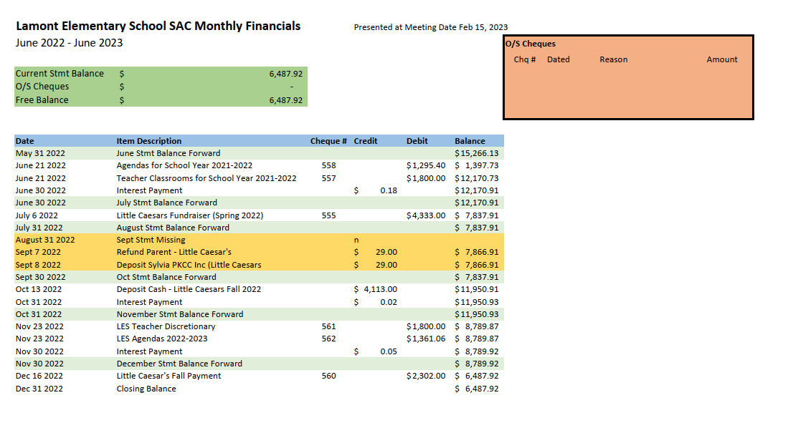

**Fundraiser Update:**Presented by Krista Skinner

Considering First Aid kits

Asking for other suggestions

Fundraising Plan for next year will be presented at September meeting to make things clear as to FLESS/SAC fundraising

Discussion regarding why SAC needs to fundraise – we donate at least $3000 to the school each year, currently focused on agendas for all students and classroom funds for teacher’s discretionary spending.

**Friends of Lamont Report:**

There will be a meeting scheduled right after the next Parent Council Meeting.

We are still waiting on news about the matching grant – should be in March 2023.

**Date of next meeting (Hybrid)** Wednesday, April 4 at 6:00pm

**Meeting Adjourned at 7:00pm** by Heather Rideout and Krista Skinner